Athena 10k ways Choreography

Animation List

Scatter | setting |  | 2
 | idle |  | 4
 | Win (triggering) |  | 6
 | Srs and shoot |  | 4
Wild | setting |  | 16
 | Idle (normal) |  | 8
 | Idle (expanded) |  | 8
 | Srs (normal) |  | 8
 | Win (normal) |  | 8
 | Win (expanded) |  | 8
 | SPEAR WILD Wild expand (from top reel, covering 4 reels) |  | 16
 | OWL COPY Wild Contagious (normal) |  | 16
FX | Changing to Wild |  | 8
 | SHIELD MULTIPLIER Win multi x5 x2 etc. |  | 6
High Symbol – B (owl) | setting |  | 12
 | idle |  | 6
 | win |  | 16
 | landing |  | 8
High Symbol – C (Poseidon) | setting |  | 12
 | idle |  | 6
 | win |  | 16
 | landing |  | 8
High Symbol – D (Ares) | setting |  | 12
 | idle |  | 6
 | win |  | 16
 | landing |  | 8
High Symbol – E (Artemis) | setting |  | 12
 | idle |  | 6
 | win |  | 16
 | landing |  | 8
Winbox | (1 second loop winbox – to show 2 seconds before explosion) |  | 6
 | (explosion fx) |  | 6
Landing FX |  |  | 6
Windup |  |  | 6
Big win | Level 1 |  | 8
 | Level 1-2 |  | 8
 | Level 2 |  | 8
 | Level 2-3 |  | 8
 | Level 3 |  | 8
Background | Basegame | B | 8
 | Freespin | B | 8
Transition | Game Intro | B | 24
 | Basegame to Freespin | B | 24
UI related animations dependent on free spins selection, welcome note, free spins intro and summary and sorry no win designs |  | B
**สีส้มยังไม่ต้องทำ - รอที่เหลือเสร็จก่อน

Animation

Scatter

Srs
Symbol | 
Loop | yes
Duration | 0.5 sec
Description | - Enlarge and shrink.

Idle
Symbol | 
Loop | yes
Duration | 10 sec
Description | - Subtle movements  - Light sweep  - Rotate slightly

Win (triggering)
Symbol | 
Loop | yes
Duration | 2 sec
Description | - Played when triggering the feature  - The shield was attacked, but showed no scratches and glowed.

Wild

Idle (normal wild)
Symbol | 
Loop | yes
Duration | 10 sec
Description | Subtle movements

Idle (expanded wild)
Symbol | 
Loop | yes
Duration | 10 sec
Description | Subtle movements

Srs
Symbol | 
Loop | yes
Duration | 0.5 sec
Description | - An effect similar to Wild SRS from Hercules.

Win (normal wild)
Symbol | 
Loop | no
Duration | 2 sec
Description | - Ends with the symbol disappeared  character dimmed, then hit helmet glows + fx explode from the helmet  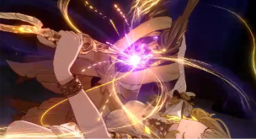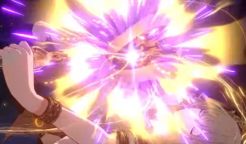  (ref - https://www.youtube.com/watch?v=pytnNja5QQY)  - Fades to white then the whole symbol disappeared

Win (expanded wild)
Symbol | 
Loop | no
Duration | 2 sec
Description | - Ends with the symbol disappeared  - character dimmed, then hit the spear on the ground + fx explode from the weapon    - (ref - https://www.youtube.com/watch?v=pytnNja5QQY)  - Fades to white then the whole symbol disappeared

Wild Expand (SPEAR WILD)
Symbol |  -> 
Loop | yes
Duration | 1-2 sec
Description | - Gold and Red fx  -  spear-shaped FXs run over the reels while the border expands from top reel (covering 4 reels)  - The goddess Athena held a spear above her head and closed her eyes as if in prayer.  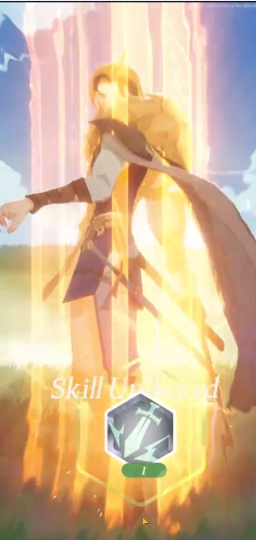 Fx ref https://www.pinterest.com/pin/610730399504469280/  - https://www.pinterest.com/pin/819232988501031203/

Wild contagious (OWL COPY)
Symbol | 
Loop | yes
Duration | 1-2 sec
Description | Option 01: Owl light FXs shoot from the center of WILD symbol to surrounding symbols  Option 02: one owl light FX grow bigger from the center of the WILD symbol (big enough to cover the surrounding symbols)  + light ring FXs behind the owl(s)

FX - Changing to wild
Symbol
Loop | yes
Duration | 1-2 sec
Description | Played over other symbols when changing to wild  - The text "WILD" appears, and the goddess Athena emerges from the center with a feather effect.

FX - Win Multi (SHIELD MULTIPLIER)
Symbol | 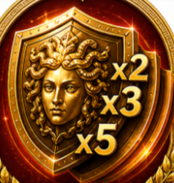
Loop | yes
Duration | - sec
Description | - Shield FXs (light/additive) stamps down the middle of the screen + Multiplier Number (x2, x3x, ... etc)

FX - Landing
Symbol
Loop | yes
Duration | 1 sec
Description | - Feather floating effect  - Plays when new symbols fill the reels after the old ones win

High Symbol B (Owl)

Landing
Symbol | 
Loop | yes
Duration | 0.5 sec
Description | Bouncing and glowing.

Idle
Symbol | 
Loop | yes
Duration | 10 sec
Description | Subtle movements

win
Symbol | 
Loop | no
Duration | 2 sec
Description | - Ends with the symbol disappeared  - character dimmed, Then the border glowed + fx explode  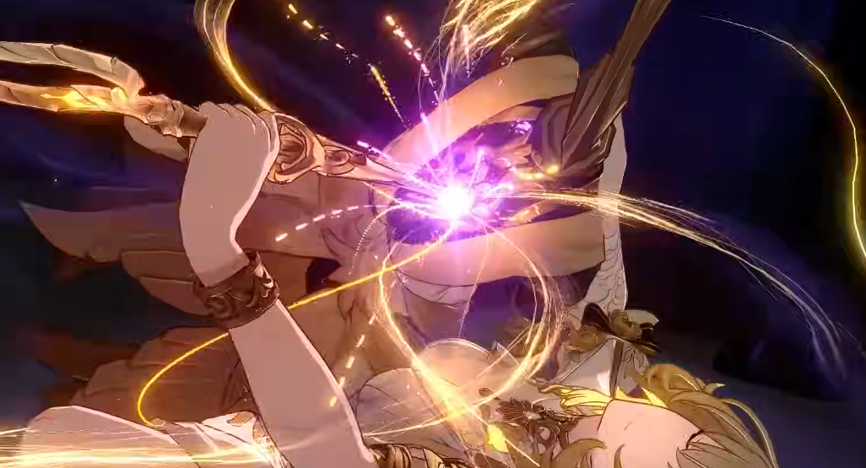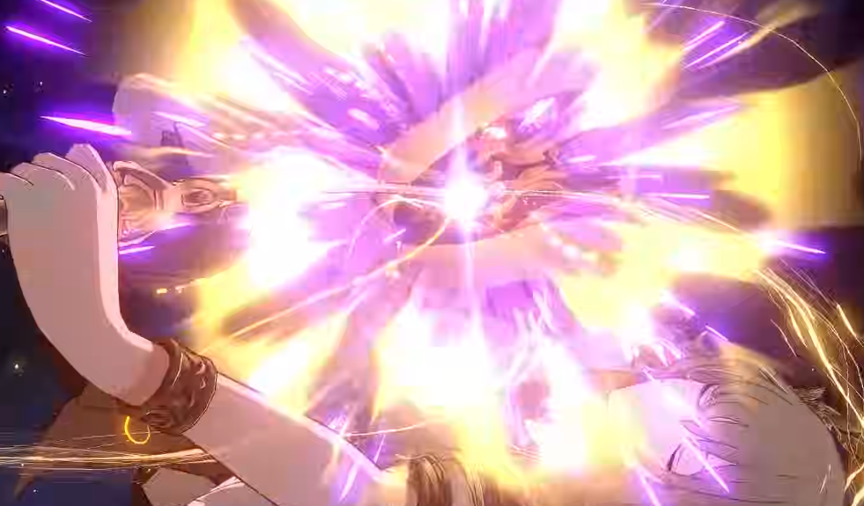  (ref - https://www.youtube.com/watch?v=pytnNja5QQY)  - Fades to white then the whole symbol disappeared

High Symbol C (Poseidon)

Landing
Symbol | 
Loop | yes
Duration | 0.5 sec
Description | Bouncing and glowing.

Idle
Symbol | 
Loop | yes
Duration | 10 sec
Description | Subtle movements

win
Symbol | 
Loop | no
Duration | 2 sec
Description | - Ends with the symbol disappeared  - character dimmed, then thrusts the trident and the border glowed + fx explode from the weapon    (ref - https://www.youtube.com/watch?v=pytnNja5QQY)  - Fades to white then the whole symbol disappeared

High Symbol D (Ares)

Landing
Symbol | 
Loop | yes
Duration | 0.5 sec
Description | Bouncing and glowing.

Idle
Symbol | 
Loop | yes
Duration | 10 sec
Description | Subtle movements

win
Symbol | 
Loop | no
Duration | 2 sec
Description | - Ends with the symbol disappeared  - character dimmed, then thrusts the sword and the border glowed + fx explode from the weapon    (ref - https://www.youtube.com/watch?v=pytnNja5QQY)  - Fades to white then the whole symbol disappeared

High Symbol E (Artemis)

Landing
Symbol | 
Loop | yes
Duration | 0.5 sec
Description | Bouncing and glowing.

Idle
Symbol | 
Loop | yes
Duration | 10 sec
Description | Subtle movements

win
Symbol | 
Loop | no
Duration | 2 sec
Description | - Ends with the symbol disappeared  - character dimmed, then shoot the bow and the border glowed + fx explode from the weapon    (ref - https://www.youtube.com/watch?v=pytnNja5QQY)  - Fades to white then the whole symbol disappeared

Winbox
Loop | yes
Description
For low symbols
- Feathers spread out from the symbol.
- Maybe explosion FX

Windup
 | 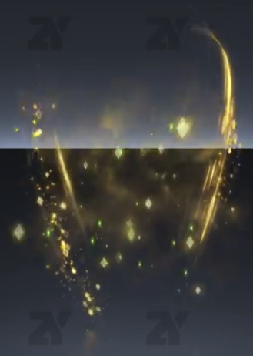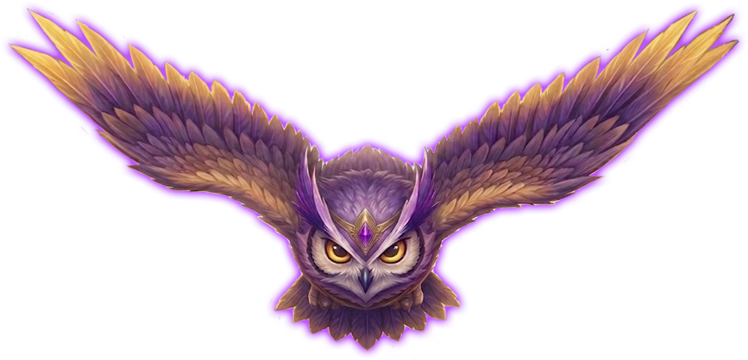
Loop | Yes
Duration | 1 sec
Description | - Feathers floated up around the symbol.  Pin on Motion Dezign  - Owl flying across the screen (after 2 SCATTER have landed, similar to FRONTIER LOCK & LOAD)

Background
Loop
Duration
Description

Transition
Game Intro transition
Loop
Duration
Description

Basegame -> Freegame transition
Loop
Duration
Description

